ASSIGNMENT 4
Q1 database named company and a table named employees with the following fields:


Q2 Insert the data into the employees table:
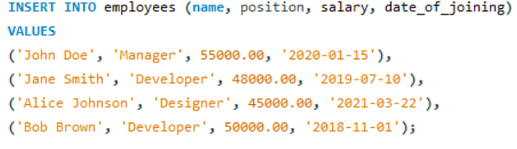
Q3Write a query to retrieve all employees who are Developers.
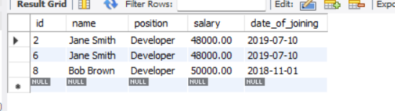
Q2 Write a query to update the salary of Alice Johnson to 46000.00.
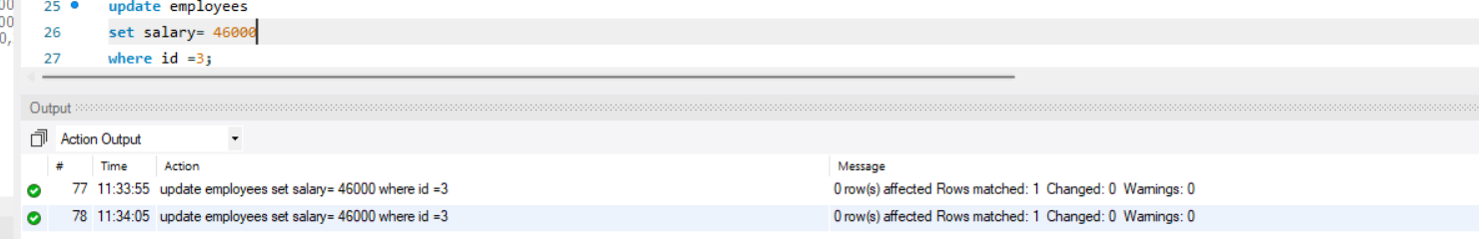
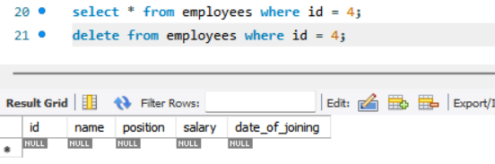
Q3 Write a query to delete the employee record for Bob Brown.
Q4 Write a query to find the employees who have a salary greater than 48000.
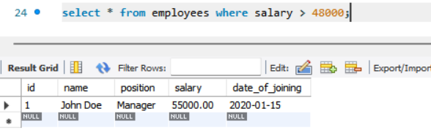

Q5 Write a query to add a new column email to the employees table.
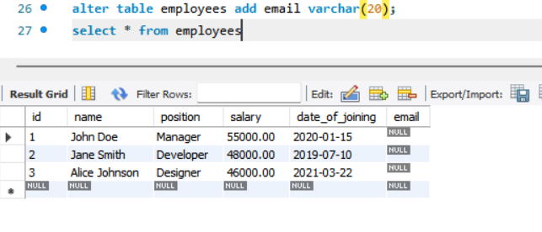

Q6 Write a query to update the email for John Doe to john.doe@company.com.
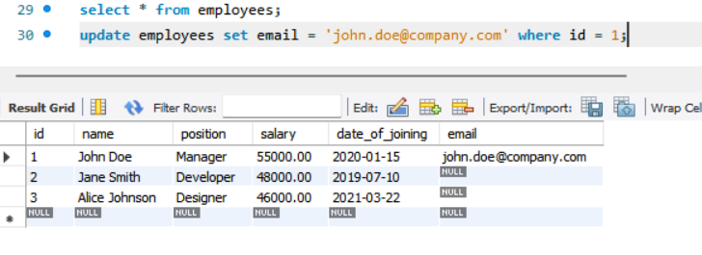

Q7 Write a query to retrieve only the name and salary of all employees.
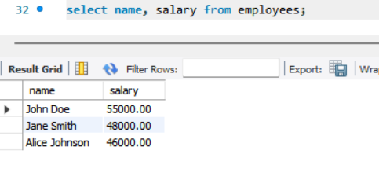

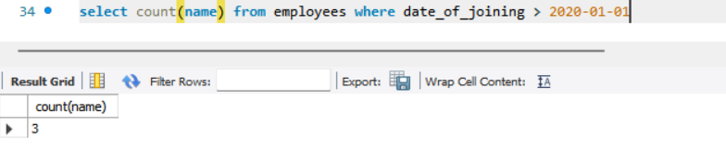
Q8 Write a query to count the number of employees who joined after January 1, 2020.

Q9 Write a query to order the employees by salary in descending order.
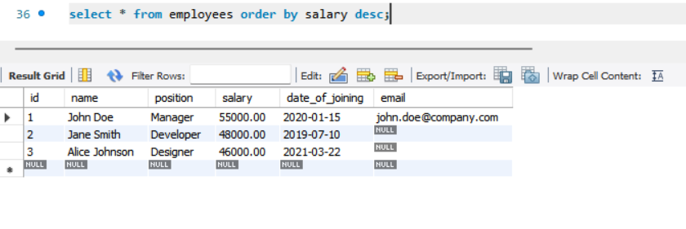

Q10 Write a query to drop the email column from the employees table.
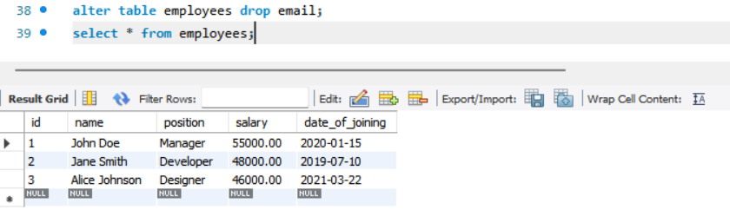

Q11 Write a query to find the employee with the highest salary.
